UNIT-1

Importance of User Interface-definition
- Definition of the User Interface:
- User interface design is a subset of a field of study called human-computer interaction (HCI). Human-computer interaction is the study, planning, and design of how people and computers work together so that a person’s needs are satisfied in the most effective way.
- The user interface is a component of a computer or its software which can be visualized, heard, touched, interacted with, run and understood by the common people or users of the computer.
The two main elements of the user interface are,
(i) Input
- In an interaction with a computer the user provides information to it.
- The data is received by the computer through input devices like keyboard, mouse, trackball, a person's finger in case of touch-screens and person's voice in case of oral commands.
- The information is all about what the user wants from the computer.
(ii) Output
- This deals with the processed information sent to the users as a result of their input.
- The output is displayed in such a way that the users can view it with their eyes on the display screen (monitor), they can hear from speakers through voice and sound.
- They can even make a copy of the information provided to them with the help of printers.
- Thus output shows how the computer responds to the users request with the help of its output devices.
Hence, the user's output becomes the computer's input and user's input becomes computer output.
The Importance of the User Interfaces
- The user interface design belongs to a field called human computer interaction.
- Human computer interaction is a technique that deals with learning, thinking and designing as to how users and computer communicates with each other.
- It gives an idea about how a person's requirements are fulfilled by the computer system in an efficient manner.
- Therefore the user interface makes the interaction between the people and the system, easy.
- The development of many new communication and display techniques leads to a package known as Graphical User Interface (GUI). The GUI has many features which are useful to the people.
(i) They help in product design through style guides.
(ii) They give instructions on how to update the design software on time.
- The WORLD WIDE WEB (www) is an important recent development in interactive computing.
- The web is built on the top of an internet and provides a simple way to access the information through graphical interfaces.
- Hence the user Interfaces simplicity and easy access by people has increased its importance and made it very useful.
- It takes into account what people desire and expect, what physical restrictions and abilities people have and what people find enjoyable and attractive.

Importance of Good Design:
- A design is said to be good if it consists of a combination of well designed input and output procedures which fulfils the user's requirements in a successful manner.
- A good design is one which possesses the following features.
- It allows its users to focus on the data and activity.
- It provides data to its users for performing their activities without using any specific procedures.
Importance of Good Design
- The interaction design means designing interactive products to support people in their everyday and working lives.
- A good-designed interface is very useful to its users for analyzing the performance of a system.
- It is a component that displays several complex activities given to the system.
- A window's layout and looks does leave an impact on the users.
- If the design is very complex, confusing and not sufficient enough then the persons will face problems at their work and commit more mistakes.
- Improper designing may develop frustration in people towards the system and they may stop using it.
- Several health problems may also arise like the people become aggressive, stressful when they do not get what they expect from the system, quickly and accurately.
Therefore the developers must focus on producing interfaces with good design features which would eventually attract its users and make their tasks simple and fast. Hence, good design is very important.
- Benefits of Good Design
- The most important benefit is that a good design increases the manufacturing rate of the product and its demand in the market by the users.
- If we make screens with weak clarity this causes the users to spend one extra second per screen. This may tend to decrease the screen usage. Hence we should improve the clarity of the screen while designing. A researcher tried to enhance screen clarity and readability by reducing the elements on the screen. Hence, the distinct objects which had been put on the same display line to conserve area, were placed on different lines accounted for twenty percent increase in the screen users. This is due to the reduction of elements on the screen and better clarity.
- Some researchers manipulated the sequence of screens and which enabled the users to compute the transactions in twenty-five percent less time and with twenty-five percent less errors in contrast to those who used original screens.
- Good designing principles caused the users to take quick decisions.
- The correct layout of data on screens increases performance and reduces the expenses of the company during its usage.
- Good designing minimizes the training costs due to less training time.
- A good design leads to great user satisfaction as stress, frustration and anger are reduced.
- The rate of customers increases due to the satisfactory service provided to them by a good design interface.
- The economical advantage of good design is that it saves a great amount of money by fixing the errors during the design process itself rather than fixing them after the product's release.
- A Brief History of Screen Design:-
IN 1970’S:-
- Initially, the cathode ray tube was used in screen designing. In the 1970s, IBM launched its 3270 cathode ray tube text-based terminal. The 3270 was used in large number of ways in offices and companies for good screen designing.
- During the 1970s less number of guidelines were available for designing.
- Designing was implemented using hardware and telephone line transmission issues.
- The 1970s screen contained several domains with unclear and unintelligible headings.
- The screen was not properly ordered and had a command area that required an information to the filled and memorized by the user.
- A reference to a manual was needed for understanding the unclear messages displayed on the screen.
- The screens displayed green text on black background, thus restricted to monochrome.
Therefore the screen of the 1970s needed huge amount of toleration and exercise by the Users in order to extract the best from the screen.

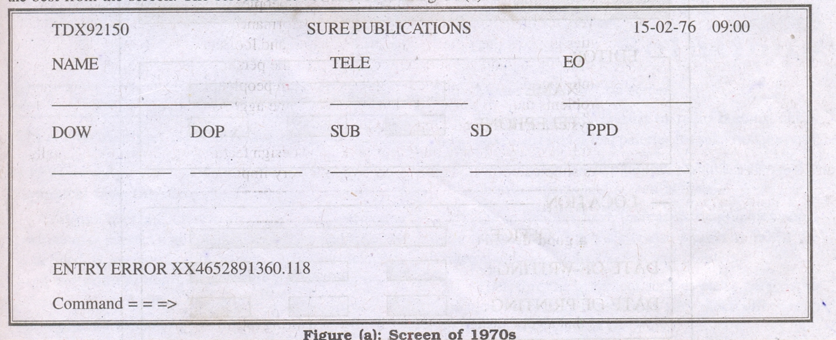

The screen of 1970s is shown in figure (a).
IN 1980’S:-

- In the 1980s a wide variety of design guidelines were launched in the market for designing screens.
- The appearances of screens were made very clear by arranging and ordering the elements.
- Assistance to the user was provided by giving clear and useful headings for the areas on the screen. Also the commands were listed nicely and were applied by function keys.
- Messages could be easily interpreted but the screen elements were not completely ordered.
- The screens contained instructions and reminders as prompts for the users. Certain codes like NN, CC, OOSD were presented on the screen to help the users in selection.

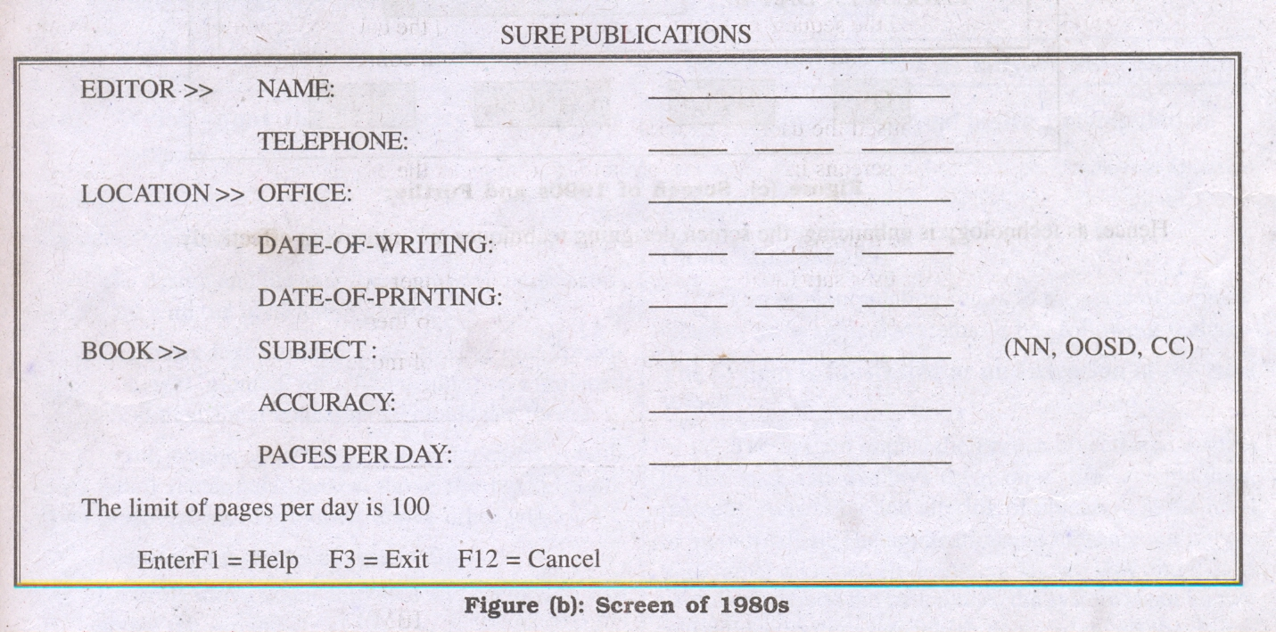

The screen of the 1980s is shown in figure (b).
IN 1990’S:-
- In the 1990s the introduction of graphics contributed a lot in screen designing.
- A long with arranging and ordering the elements, borders were also included to usually enhance groupings.
- The commands were now handled by buttons and menus rather than function keys.
- Elements had numerous features such as a variety of font sizes, styles, line thickness and colors.
- List-boxes drop-down combination boxes, spin-boxes were used for making entries.
- The users did not need to memorize anything as everything was listed in the controls provided on the screen.
- The codes were removed from the screen and new listing control was inscribed.

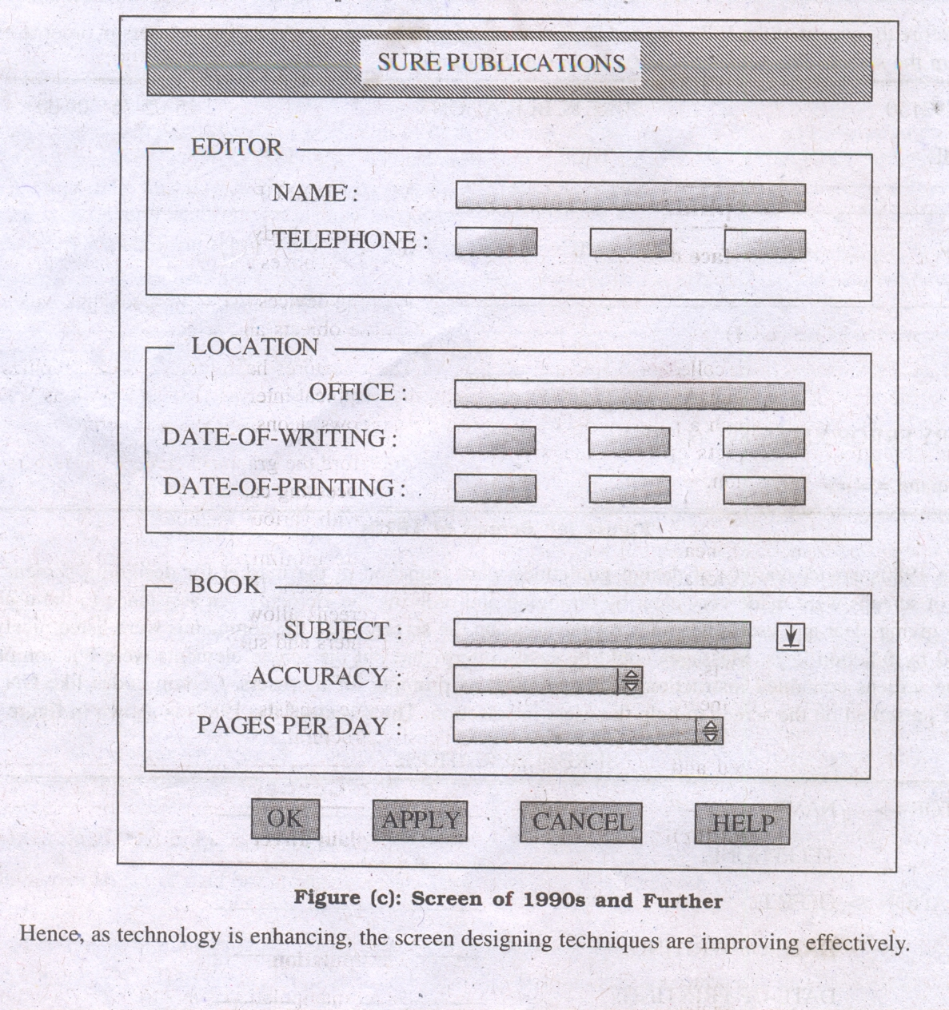

The screen of 1990s is shown in figure (c),

PART II (The Graphical User Interface)

The Graphical User Interface
- A user interface is a collection of techniques and mechanisms to interact with something.
- In a graphical interface the primary interaction mechanism is a pointing device of some kind. This device is the electronic equivalent to the human hand. What the user interacts with is a collection of elements referred to as objects.
- They can be seen, heard, touched, or otherwise perceived.
- Objects are always visible to the user and are used to perform tasks. They are interacted with as entities independent of all other objects.
- People perform operations, called actions, on objects. The operations include accessing and modifying objects by pointing, selecting, and manipulating. All objects have standard resulting behaviors.
- Popularity of Graphics:
- A graphical screen bore scant resemblance to its earlier text-based colleagues. The older text-based screen possessed a one dimensional.Graphic screens assumed a three-dimensional look.
- Controls appeared to rise above the screen and move when activated.
- Information could appear, and disappear, as needed.
- Text could be replaced by graphical images called icons. These icons could represent objects or actions.
- Screen navigation & commands are executed through menu bars & pull-downs.
- Menu “pop-up” on the screen. In the screen body, selection fields such as radio buttons, check boxes, list boxes, and palettes coexisted with the reliable old text entry field.
- More sophisticated text entry fields with attached or drop-down menus of alternatives also became available.
- Screen objects and actions were selected through use of pointing mechanisms such as the mouse or joystick, instead of the traditional keyboard.
- Increased computer power and the vast improvement in the display enable the user’s actions to be reacted to quickly, dynamically, and meaningfully.
- This new interface is characterized as representing one’s “desktop” with scattered notes, papers, and objects such as files, trays, and trashcans arrayed around the screen. It is sometimes referred to as the WIMP interface: windows, icons, menus, and pointers.
- Graphic presentation is much more effective than other presentation methods.
- Properly used, it reduces the requirement for perceptual and mental information recoding and reorganization, and also reduces the memory loads.
- It permits faster information transfer between computers and people by permitting more visual comparisons of amounts, trends, or relationships; more compact representation of information;
- Graphics also can add appeal or charm to the interface and permit greater customization to create a unique corporate or organization style.
Graphical Systems: Advantages:
- Symbols recognized faster than text: Research has found that symbols can be recognized faster and more accurately than text, and that the graphical attributes of icons, such as shape and color, are very useful for quickly classifying objects, elements, or text by some common property.
- Faster learning: Research has also found that a graphical, pictorial representation aids learning, and symbols can also be easily learned.
- Faster use and problem solving: Visual or spatial representation of information has been found to be easier to retain and manipulate and leads to faster and more successful problem solving. Symbols have also been found to be effective in conveying simple instructions.
- Easier remembering: Because of greater simplicity, it is easier for casual users to retain operational concepts.
- More natural: Graphic representations of objects are thought to be more natural and closer to innate human capabilities. In human beings, actions and visual skills emerged before languages. It has also been suggested that symbolic displays are more natural and advantageous because the human mind has a powerful image memory.
- Exploits visual/spatial cues: Spatial relationships are usually found to be understood more quickly than verbal representations. Visually thinking is believed to be better than logical thinking.
- Fosters more concrete thinking: Displayed objects are directly in the high-level task domain, or directly usable in their presented form. There is no need mentally to decompose tasks into multiple commands with complex syntactic form. The need for abstract thinking is therefore minimized.
- Provides context: Displayed objects are visible, providing a picture of the current context.
- Fewer errors: More concrete thinking affords fewer opportunities for errors. Reversibility of actions reduces error rates because it is always possible to undo the last step. Error messages are less frequently needed.
- Increased feeling of control: The user initiates actions and feels in control. This increases user confidence and hastens system mastery.
- Immediate feedback: The results of actions furthering user goals can be seen immediately. Learning is quickened. If the response is not in the desired direction, the direction can be changed quickly.
- Predictable system responses: Predictable system responses also speed learning.
- Easily reversible actions: The user has more control. This ability to reverse unwanted actions also increases user confidence and hastens system mastery.
- Less anxiety concerning use: Hesitant or new users feel less anxiety when using the system because it is so easily comprehended, is easy to control, and has predictable responses and reversible actions.
- More attractive: Direct-manipulation systems are more entertaining, cleverer, and more appealing. This is especially important for the cautious or skeptical user.
- May consume less space: Icons may take up less space than the equivalent in words. More information can often be packed in a given area of the screen. This, however, is not always the case.
- Replaces national languages: Language-based systems are seldom universally applicable. Language translations frequently cause problems in a text-based system. Icons possess much more universality than text and are much more easily comprehended worldwide.
- Easily augmented with text displays: Where graphical design limitations exist, direct-manipulation systems can easily be augmented with text displays. The reverse is not true.
- Low typing requirements: Pointing and selection controls, such as the mouse or trackball, eliminate the need for typing skills.
- Smooth transition from command language system: Moving from a command language to a direct-manipulation system has been found to be easy. The reverse is not true.

Graphical system disadvantages:
The body of positive research, hypotheses, and comment concerning graphical systems is being challenged by some studies, findings, and opinions that indicate that graphical representation and interaction may not necessarily always be better. Indeed, in some cases, it may be poorer than pure textual or alphanumeric displays. Sometimes arcane, and even bizarre. Among the disadvantages put forth are these:
- Greater design complexity: Controls and basic alternatives must be chosen from a pile of choices numbering in excess of 50. This design potential may not necessarily result in better design unless proper controls and windows are selected. Poor design can undermine acceptance.
- Learning still necessary: The first time one encounters many graphical systems, what to do is not immediately obvious. A severe learning and remembering requirement is imposed on many users because meanings of icons or using pointing device have to be learned.
- Lack of experimentally-derived design guidelines: today there is a lack of widely available experimentally-derived design guidelines. Earlier only few studies to aid in making design decisions were performed and available for today now. Consequently, there is too little understanding of how most design aspects relate to productivity and satisfaction.
- Inconsistencies in technique and terminology: Many differences in technique, terminology, and look and feel exist among various graphical system providers, and even among successive versions of the same system. So the user has to learn or relearn again while shifting to next terminology.
- Not always familiar: Symbolic representations may not be as familiar as words or numbers. Numeric symbols elicit faster responses than graphic symbols in a visual search task.
- Window manipulation requirements: Window handling and manipulation times are still excessive and repetitive. This wastes time
- Production limitations: The number of symbols that can be clearly produced using today’s technology is still limited. A body of recognizable symbols must be produced that are equally legible and equally recognizable using differing technologies. This is extremely difficult today.
- Few tested icons exist: Icons must be researched, designed, tested, and then introduced into the marketplace. The consequences of poor or improper design will be confusion and lower productivity for users.
- Inefficient for touch typists: For an experienced touch typist, the keyboard is a very fast and powerful device.
- Not always the preferred style of interaction: Not all users prefer a pure iconic interface. User will also prefer alternatives with textual captions.
- Not always fastest style of interaction: graphic instructions on an automated bank teller machine were inferior to textual instructions.
- May consume more screen space: Not all applications will consume less screen space. A listing of names and telephone numbers in a textual format will be more efficient to scan than a card file.
- Hardware limitations: Good design also requires hardware of adequate power, processing speed, screen resolution, and graphic capability.
- The Concept of Direct Manipulation:
The term used to describe this style of interaction for graphical systems was first used by Shneiderman (1982). He called them “direct manipulation” systems, suggesting that they possess the following characteristics:

The system is portrayed as an extension of the real world:
- It is assumed that a person is already familiar with the objects and actions in his or her environment of interest.
- The system simply replicates them and portrays them on a different medium, the screen.
- A person has the power to access and modify these objects, among which are windows.
- A person is allowed to work in a familiar environment and in a familiar way, focusing on the data, not the application and tools.
- The physical organization of the system, which most often is unfamiliar, is hidden from view and is not a distraction.
Continuous visibility of objects and actions:
Like one's desktop, objects are continuously visible. Reminders of actions to be performed are also obvious, labeled buttons replacing complex syntax and command names.
- Cursor action and motion occurs in physically obvious and natural ways. One problem in direct manipulation, however, is that there is no direct analogy on the desk for all necessary windowing operations.
- A piece of paper on one's desk maintains a constant size, never shrinking or growing. Windows can do both. Solving this problem required embedding a control panel, a familiar concept to most people, in a window's border.
- This control panel is manipulated, not the window itself. Actions are rapid and incremental with visible display of results, the results of actions are immediately displayed visually on the screen in their new and current form.
- Auditory feedback may also be provided. The impact of a previous action is quickly seen, and the evolution of tasks is continuous and effortless. Incremental actions are easily reversible.
Actions are rapid and incremental with visible display of results: the results of actions are immediately displayed visually on the screen in their new and current form. Auditory feedback may also be provided. The impact of a previous action is quickly seen, and the evolution of tasks is continuous and effortless.
Incremental actions are easily reversible: Finally, actions, if discovered to be incorrect or not desired, can be easily undone.

Earlier Direct Manipulation Systems:
- The concept of direct manipulation actually preceded the first graphical system. The earliest full-screen text editors possessed similar characteristics.
- Screens of text resembling a piece of paper on one's desk could be created (extension of real world) and then reviewed in their entirety (continuous visibility).
- Editing or restructuring could be easily accomplished (through rapid incremental actions) and the results immediately seen.
- Actions could be reversed when necessary. It took the advent of graphical systems to crystallize the direct manipulation concept, however.
Indirect Manipulation:
- In practice, direct manipulation of all screen objects and actions may not be feasible because of the following:
- The operation may be difficult to conceptualize in the graphical system.
- The graphics capability of the system may be limited.
- The amount of space available for placing manipulation controls in the window border may be limited.
- It may be difficult for people to learn and remember all the necessary operations and actions.
- When this occurs, indirect manipulation is provided. Indirect manipulation substitutes words and text, such as pull-down or pop-up menus, for symbols, and substitutes typing for pointing.
- Most window systems are a combination of both direct and indirect manipulation. A menu may be accessed by pointing at a menu icon and then selecting it (direct manipulation).
- The menu itself, however, is a textual list of operations (indirect manipulation). When an operation is selected from the list, by pointing or typing, the system executes it as a command.
- Which style of interaction-direct manipulation, indirect manipulation, or a combination of both-is best, under what conditions and for whom, remains a question whose answer still eludes us.
- Characteristics of the Graphical User Interface:
A graphical system possesses a set of defining concepts. Included are sophisticated visual presentation, pick-and-click interaction, a restricted set of interface options, visualization, object orientation, extensive use of a person's recognition memory, and concurrent performance of functions.
- Sophisticated Visual Presentation: Visual presentation is the visual aspect of the interface. It is what people see on the screen.
- The sophistication of a graphical system permits displaying lines, including drawings and icons.
- It also permits the displaying of a variety of character fonts, including different sizes and styles.
- The display of 16 million or more colors is possible on some screens. Graphics also permit animation and the presentation of photograph and motion video.
- The meaningful interface elements visually presented to the user in a graphical System include windows (primary, secondary, or dialog boxes), menus (menu bar, pull down, pop-up, cascading), icons to represent objects such as programs or files, assorted screen-based controls (text boxes, list boxes, combination boxes, settings, scroll bar and buttons), and a mouse pointer and cursor. The objective is to reflect visually on screen the real world of the user as realistically, meaningfully, simply, and clearly possible.
A graphical system possesses a set of defining concepts. Included are sophisticated visual presentation, pick-and-click interaction, a restricted set of interface options, visualization, object orientation, extensive use of a person's recognition memory, and concurrent performance of functions.
- Restricted Set of Interface Options: The array of alternatives available to the user is what is presented on the screen or may be retrieved through what is presented on the screen, nothing less, and nothing more. This concept fostered the acronym WYSIWYG.
- Pick-and-Click Interaction: Elements of a graphical screen upon which some action is to be performed must first identified.
- The motor activity required of a person to identify this element for a proposed action is commonly referred to as pick, the signal to perform an action as cue.
- The primary mechanism for performing this pick-and-click is most often the mouse and its buttons.
- The user moves the mouse pointer to the relevant element (pick) and the action is signaled (click).
- Pointing allows rapid selection and feedback. The hand and mind seem to work smoothly and efficiently together.
- The secondary mechanism for performing these selection actions is the keyboard most systems permit pick-and-click to be performed using the keyboard as well.
- Visualization: Visualization is a cognitive process that allows people to understand Information that is difficult to perceive, because it is either too voluminous or too abstract Presenting specialized graphic portrayals facilitates visualization.
- The best visualization method for an activity depends on what People are trying to learn from the data.
- The goal is not necessarily to reproduce a really graphical image, but to produce one that conveys the most relevant information.
- Effective visualizations can facilitate mental insights, increase productivity, and for faster and more accurate use of data.
- Object Orientation: A graphical system consists of objects and actions. Objects are what people see on screen. They are manipulated as a single unit.
- Objects can be composed of sub objects. For example, an object may be a document. The document's sub objects may be a paragraph, sentence, word, and letter. A collection is the simplest relationship-the objects sharing a common aspect.
- A collection might be the result of a query or a multiple selection of objects. Operations can be applied to a collection of objects.
- A constraint is a stronger object relationship. Changing an object in a set affects some other object in the set.
A document being organized into pages is an example of a constraint.
- A composite exists when the relationship between objects becomes so significant that the aggregation itself can be identified as an object.Examples include a range of cells organized into a spreadsheet, or a collection of words organized into a paragraph.
- A container is an object in which other objects exist. Examples include text in a document or documents in a folder. A container often influences the behavior of its content. It may add or suppress certain properties or operations of objects placed within it, control access to its content, or control access to kinds of objects it will accept.
These relationships help define an object's type. Similar traits and behaviors exist in objects of the same object type.
- Another important object characteristic is persistence. Persistence is the maintenance of a state once it is established. An object's state (for example, window size, cursor location, scroll position, and so on) should always be automatically preserved when the user changes it.
- Use of Recognition Memory: Continuous visibility of objects and actions encourages use of a person's more powerful recognition memory.
The "out of sight, out of mind" problem is eliminated.
Concurrent Performance of Functions
- Graphic systems may do two or more things at one time. Multiple programs may run simultaneously. When a system is not busy on a primary task, it may process background tasks (cooperative multitasking).
- When applications are running as truly separate tasks, the system may divide the processing power into time slices and allocate portions to each application.
- Data may also be transferred between programs. It may be temporarily stored on a "clipboard" for later transfer or be automatically swapped between programs.

PART III (Web User)

- Interface Popularity:
- The expansion of the World Wide Web since the early 1990s has been truly amazing.
Once simply a communication medium for scientists and researchers, its many and pervasive tentacles have spread deeply into businesses, organizations, and homes around the world.
- Unlike earlier text-based and GUI systems that were developed and nurtured in an organization's Data Processing and Information Systems groups, the Web's roots were sown in a market-driven society thirsting for convenience and information.
- Web interface design is essentially the design of navigation and the presentation of information. It is about content, not data.
- Proper interface design is largely a matter of properly balancing the structure and relationships of menus, content, and other linked documents or graphics.
- The design goal is to build a hierarchy of menus and pages that feels natural, is well structured, is easy to use, and is truthful.
- The Web is a navigation environment where people move between pages of information, not an application environment. It is also a graphically rich environment.
- Web interface design is difficult for a number of reasons. First, its underlying design language, HTML, was never intended for creating screens to be used by the general population.
- Its scope of users was expected to be technical. HTML was limited in objects and interaction styles and did not provide a means for presenting information in the most effective way for people.
- Next, browser navigation retreated to the pre-GUI era. This era was characterized by a "command" field whose contents had to be learned, and a navigational organization and structure that lay hidden beneath a mostly dark and blank screen.
- GUIs eliminated the absolute necessity for a command field, providing menus related to the task and the current contextual situation.
- Browser navigation is mostly confined to a "Back" and "Forward" concept, but "back-to-where" and "forward-to-where" is often unremembered or unknown.
- Web interface design is also more difficult because the main issues concern information architecture and task flow, neither of which is easy to standardize.
- It is more difficult because of the availability of the various types of multimedia, and the desire of many designers to use some thing simply because it is available.
- It is more difficult because users are ill defined, and the user's tools so variable in nature.
- The ultimate goal of a Web that feels natural, is well structured, and is easy to use will reach fruition.
The Popularity of the Web:
- While the introduction of the graphical user interface revolutionized the user interface, the Web has revolutionized computing.
- It allows millions of people scattered across the globe to communicate, access information, publish, and be heard.
- It allows people to control much of the display and the rendering of Web pages.
- Aspects such as typography and colors can be changed, graphics turned off, and decisions made whether or not to transmit certain data over non secure channels or whether to accept or refuse cookies.
- Web usage has reflected this popularity. The number of Internet hosts has risen dramatically:
- In 1984, hosts online exceeded 1,000;
- in 1987, 10,000;
- in 1989, 100,000,
- in 1990, 300,000;
- In 1992 hosts exceeded one million.
- Commercialization of the Internet saw even greater expansion of the growth rate. In 1993, Internet traffic was expanding at a 341,634 percent annual growth rate. In 1996, there were nearly 10 million hosts online and 40 million connected people (PBS Timeline).
- User control has had some decided disadvantages for some Web site owners as well.
- Users have become much more discerning about good design.
- Slow download times, confusing navigation, confusing page organization, disturbing animation, or other undesirable site features often results in user abandonment of the site for others with a more agreeable interface.
- People are quick to vote with their mouse, and these warnings should not go unheeded.
- User control has had some decided disadvantages for some Web site owners as well.
- Users have become much more discerning about good design.
- Slow download times, confusing navigation, confusing page organization, disturbing animation, or other undesirable site features often results in user abandonment of the site for others with a more agreeable interface.
- People are quick to vote with their mouse, and these warnings should not go unheeded.
- Characteristics of a Web Interface
A Web interface possesses a number of characteristics, some similar to a GUI interface, and, as has already been shown, some different. In the following paragraphs many of these specific commonalities and differences will be examined. Also, the differing characteristics of printed page design and Web page design will be compared.
GUI versus Web Page Design
- GUI and Web interface design do have similarities. Both are software designs, they are used by people, they are interactive, they are heavily visual experiences presented through screens, and they are composed of many similar components.
- Significant differences do exist.

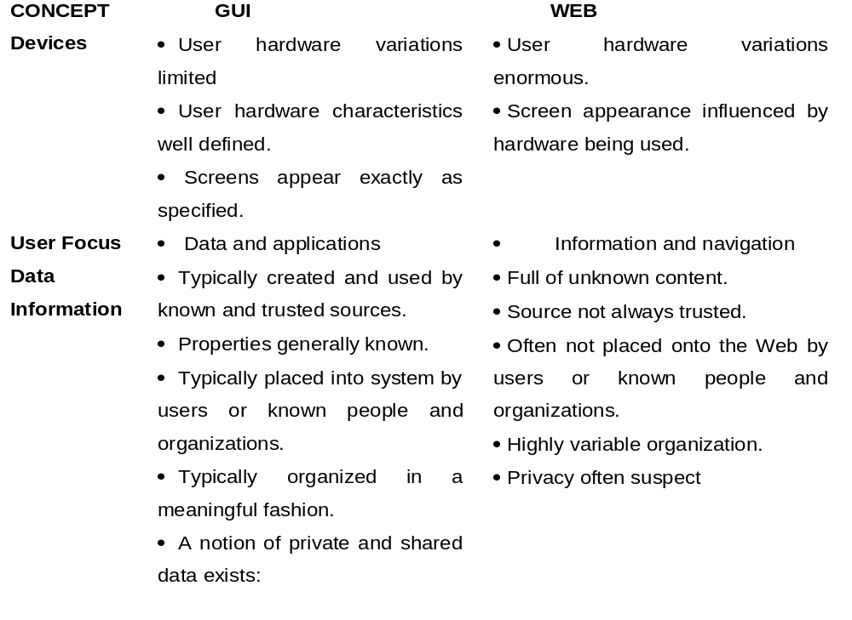

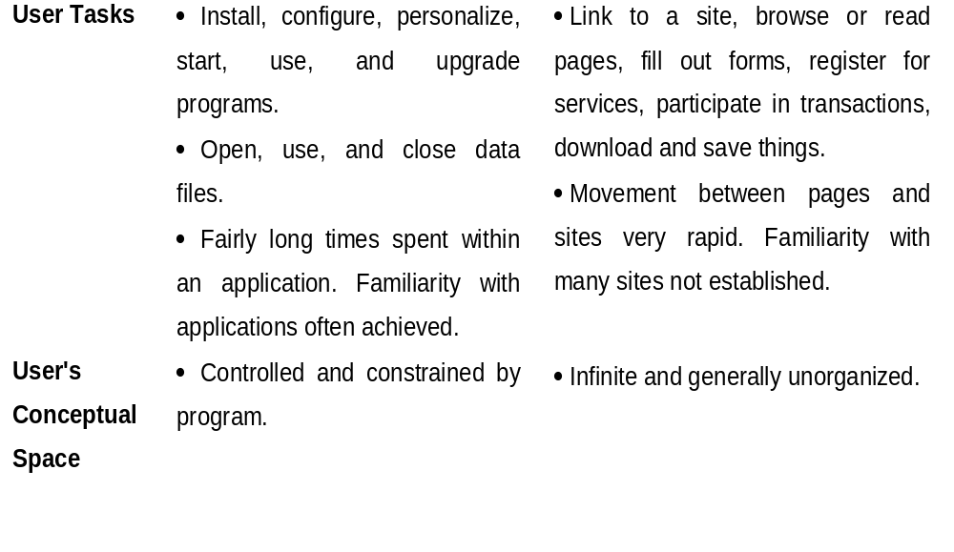

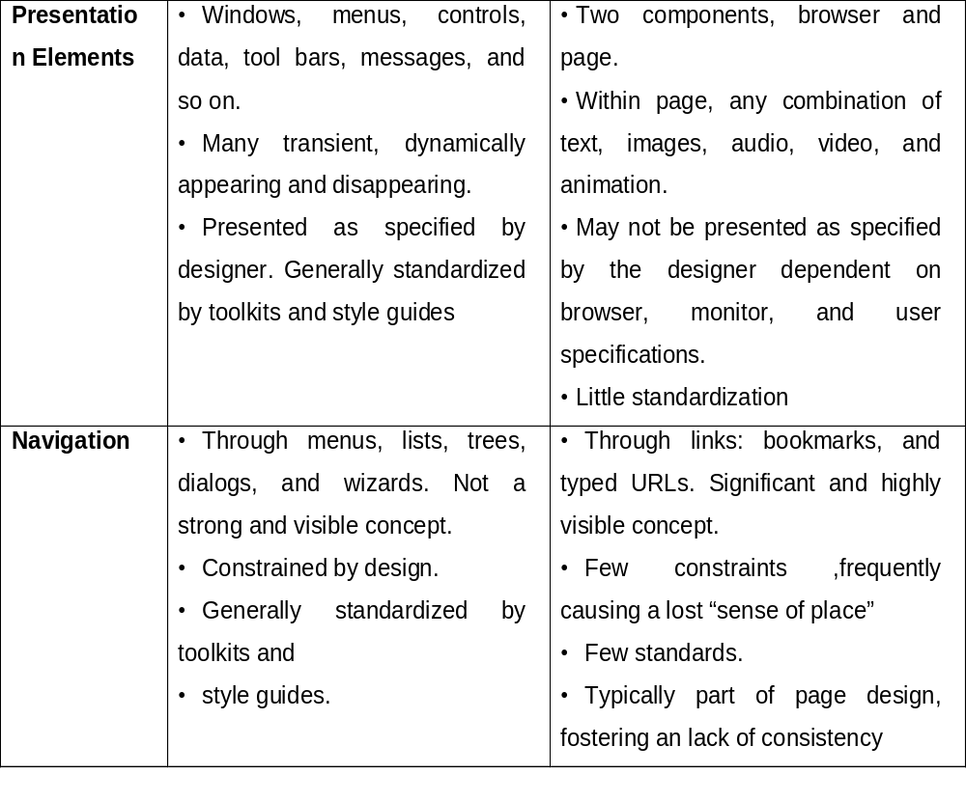

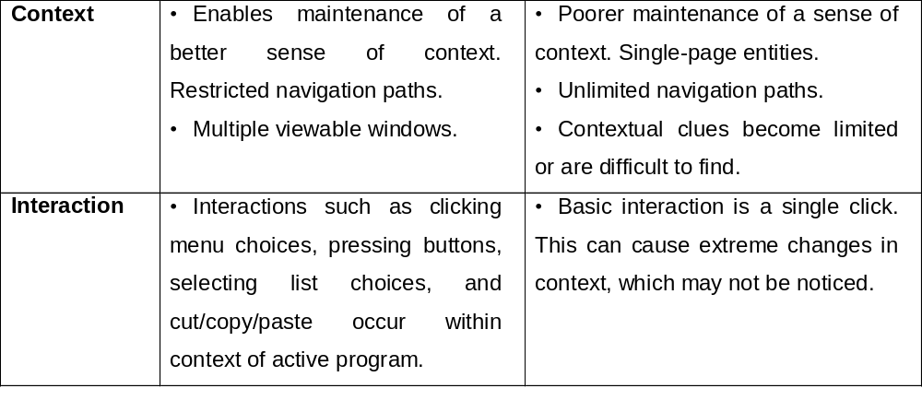

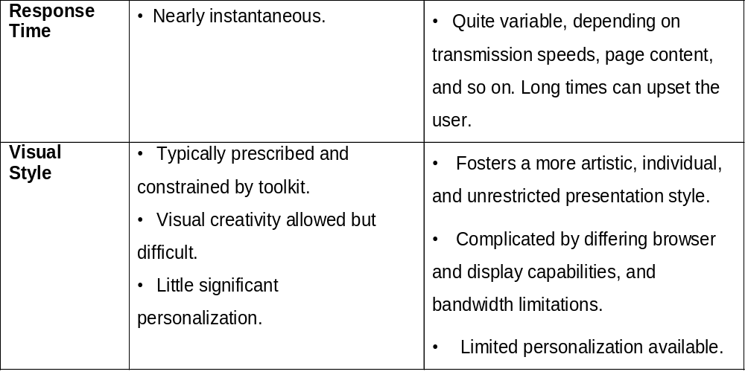

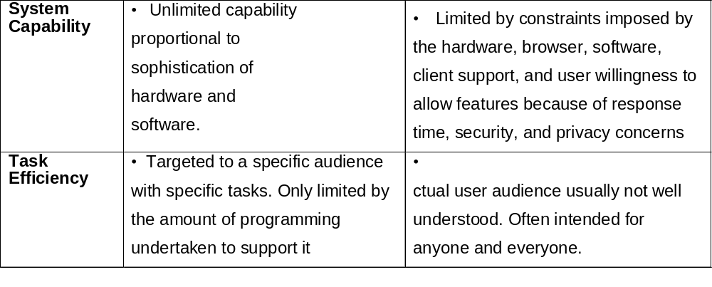

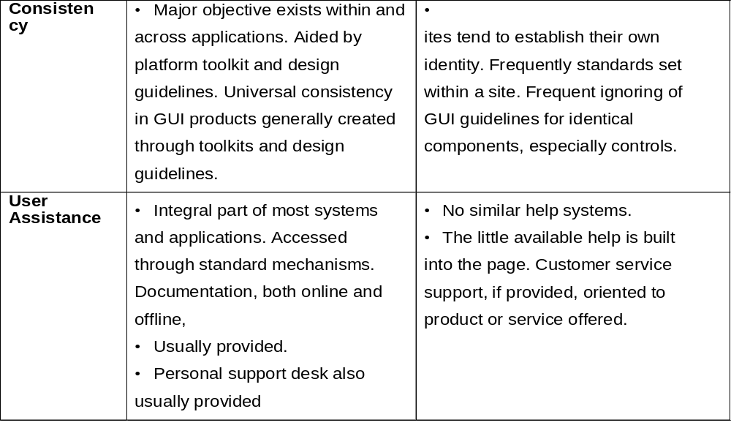

- PRINCIPLES OF USER INTERFACE DESIGN:
- An interface must really be just an extension of a person. This means that the system and its software must reflect a person's capabilities and respond to his or her specific needs.
- It should be useful, accomplishing some business objectives faster and more efficiently than the previously used method or tool did.
- It must also be easy to learn, for people want to do, not learn to do.
- Finally, the system must be easy and fun to use, evoking a sense of pleasure and accomplishment not tedium and frustration.
- The interface itself should serve as both a connector and a separator:
- A connector in that it ties the user to the power of the computer, and a separator in that it minimizes the possibility of the participants damaging one another.
- While the damage the user inflicts on the computer tends to be physical (a frustrated pounding of the keyboard), the damage caused by the computer is more psychological.
- Throughout the history of the human-computer interface, various researchers and writers have attempted to define a set of general principles of interface design.
- What follows is a compilation of these principles. They reflect not only what we know today, but also what we think we know today.
- Many are based on research, others on the collective thinking of behaviorists working with user interfaces.
- These principles will continue to evolve, expand, and be refined as our experience with Gills and the Web increases.
Principles for the Xerox STAR:
- The design of the Xerox STAR was guided by a set of principles that evolved over its lengthy development process. These principles established the foundation for graphical interfaces.
- Displaying objects that are selectable and manipulable must be created.
- A design challenge is to invent a set of displayable objects that are represented meaningfully and appropriately for the intended application.
- It must be clear that these objects can be selected, and how to select them must be self-evident.
- When they are selected should also be obvious, because it should be clear that the selected object will be the focus of the next action. Standalone icons easily fulfilled this requirement.
- The handles for windows were placed in the borders.
- Visual order and viewer focus: Attention must be drawn, at the proper time, to the important and relevant elements of the display.
- Effective visual contrast between various components of the screen is used to achieve this goal.
- Animation is also used to draw attention, as is sound. Feedback must also be provided to the user.
- Since the pointer is usually the focus of viewer attention, it is a useful mechanism for providing this feedback (by changing shapes).
- Revealed structure: The distance between one's intention and the effect must be minimized.
- Most often, the distance between intention and effect is lengthened as system power increases.
- The relationship between intention and effect must be, tightened and made as apparent as possible to the user.
- The underlying structure is often revealed during the selection process.
- Consistency: Consistency aids learning. Consistency is provided in such areas as element location, grammar, font shapes, styles, and sizes, selection indicators, and contrast and emphasis techniques
- Appropriate effect or emotional impact: The interface must provide the appropriate emotional effect for the product and its market.
Is it a corporate, professional, and secure business system? Should it reflect the fantasy, wizardry, and bad puns of computer games?
- A match with the medium: The interface must also reflect the capabilities of the device on which it will be displayed.
Quality of screen images will be greatly affected by a device's resolution and color-generation capabilities.
General Principles:
- The design goals in creating a user interface are described below.
- They are fundamental to the design and implementation of all effective interfaces, including GUI and Web ones.
- These principles are general characteristics of the interface, and they apply to all aspects.
- The compilation is presented alphabetically, and the ordering is not intended to imply degree of importance.
Aesthetically Pleasing
Provide visual appeal by following these presentation and graphic design principles:
- Provide meaningful contrast between screen elements.
- Create groupings.
- Align screen elements and groups.
- Provide three-dimensional representation.
- Use color and graphics effectively and simply.
Clarity
The interface should be visually, conceptually, and linguistically clear, including
- Visual elements
- Functions
- Metaphors
- Words and Text
Compatibility
>> Provide compatibility with the following:
- The user
- The task and job
- The Product
>> Adopt the User’s Perspective
Configurability
>> Permit easy personalization, configuration, and reconfiguration of settings.
- Enhances a sense of control
- Encourages an active role in understanding
Comprehensibility
>> A system should be easily learned and understood: A user should know the following:
- What to look at
- What to do
- When to do it
- Where to do it
- Why to do it
- How to do it
>> The flow of actions, responses, visual presentations, and information should be in a sensible order that is easy to recollect and place in context.
Consistency
>> A system should look, act, and operate the same throughout. Similar components should:
- Have a similar look.
- Have similar uses.
- Operate similarly.
>> The same action should always yield the same result
>> The function of elements should not change.
>> The position of standard elements should not change.
Control
>>The user must control the interaction.
  - Actions should result from explicit user requests.
  - Actions should be performed quickly.
  - Actions should be capable of interruption or termination.
  - The user should never be interrupted for errors
>>The context maintained must be from the perspective of the user.
>>The means to achieve goals should be flexible and compatible with the user's skills, experiences, habits, and preferences.
>>Avoid modes since they constrain the actions available to the user.
>>Permit the user to customize aspects of the interface, while always providing a Proper set of defaults.
Directness
>> Provide direct ways to accomplish tasks.
- Available alternatives should be visible.
- The effect of actions on objects should be visible.
Flexibility
>> A system must be sensitive to the differing needs of its users, enabling a level and type of performance based upon:
- Each user's knowledge and skills.
- Each user's experience.
- Each user's personal preference.
- Each user's habits.
- The conditions at that moment.
Efficiency
>> Minimize eye and hand movements, and other control actions.
- Transitions between various system controls should flow easily and freely.
- Navigation paths should be as short as possible.
- Eye movement through a screen should be obvious and sequential.
>> Anticipate the user's wants and needs whenever possible.
Familiarity
>>Employ familiar concepts and use a language that is familiar to the user.
>> Keep the interface natural, mimicking the user's behavior patterns.
>> Use real-world metaphors.
Forgiveness
>>Tolerate and forgive common and unavoidable human errors.
>>Prevent errors from occurring whenever possible.
>> Protect against possible catastrophic errors.
>> When an error does occur, provide constructive messages.
Predictability
>>The user should be able to anticipate the natural progression of each task.
- Provide distinct and recognizable screen elements.
- Provide clues to the result of an action to be performed.
>>All expectations should be fulfilled uniformly and completely.
Recovery
>> A system should permit:
  - Commands or actions to be abolished or reversed.
  - Immediate return to a certain point if difficulties arise.
>> Ensure that users never lose their work as a result of:
  - An error on their part.
  - Hardware, software, or communication problems.
Responsiveness
>> The system must rapidly respond to the user's requests.
>> Provide immediate acknowledgment for all user actions:
    - Visual.
    - Textual
    - Auditory.
Transparency
>> Permit the user to focus on the task or job, without concern for the mechanics of the interface.
- Workings and reminders of workings inside the computer should be invisible to the user.
Simplicity
>>Provide as simple an interface as possible.
>> Five ways to provide simplicity:
- Use progressive disclosure, hiding things until they are needed
    - Present common and necessary functions first
    - Prominently feature important functions
    - Hide more sophisticated and less frequently used functions.
      - Provide defaults.
      - Minimize screen alignment points.
      - Make common actions simple at the expense of uncommon actions being made harder.
      - Provide uniformity and consistency.

